**1. Open terminal and create a project**

composer create-project laravel/laravel sample

vendorname/package projectname

**2.Open the created project sample in the VSCode**

**3**. then open the terminal and type this

**php artisan serve**

Follow link to view the Laravel homepage

*Resources->Routes->web.php*

**4.CREATING A CONTROLLER**

php artisan make:controller HomeController

*app->http->controller->homecontroller*

**5. In homecontroller type the homepage()**

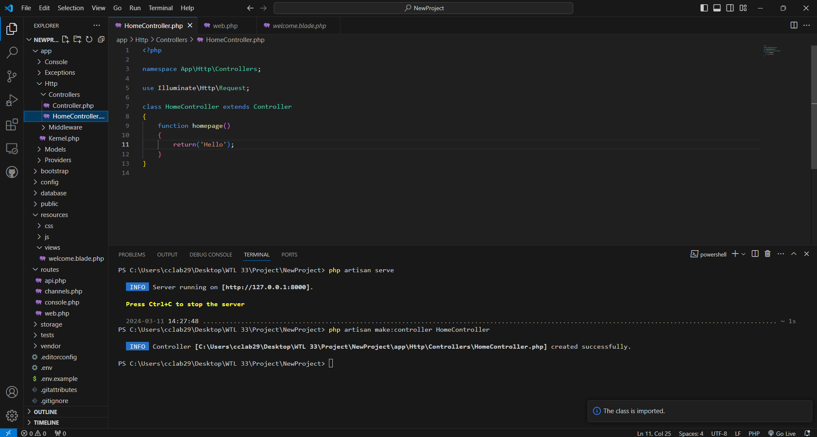

**6. In the sample folder, routes->web.php specify the route**

[install php namespace resolver]

Web.php

Route::get('/', [HomeController::Class,'homepage']);

Change the default function to this

Then right click and import class

use App\Http\Controllers\HomeController;

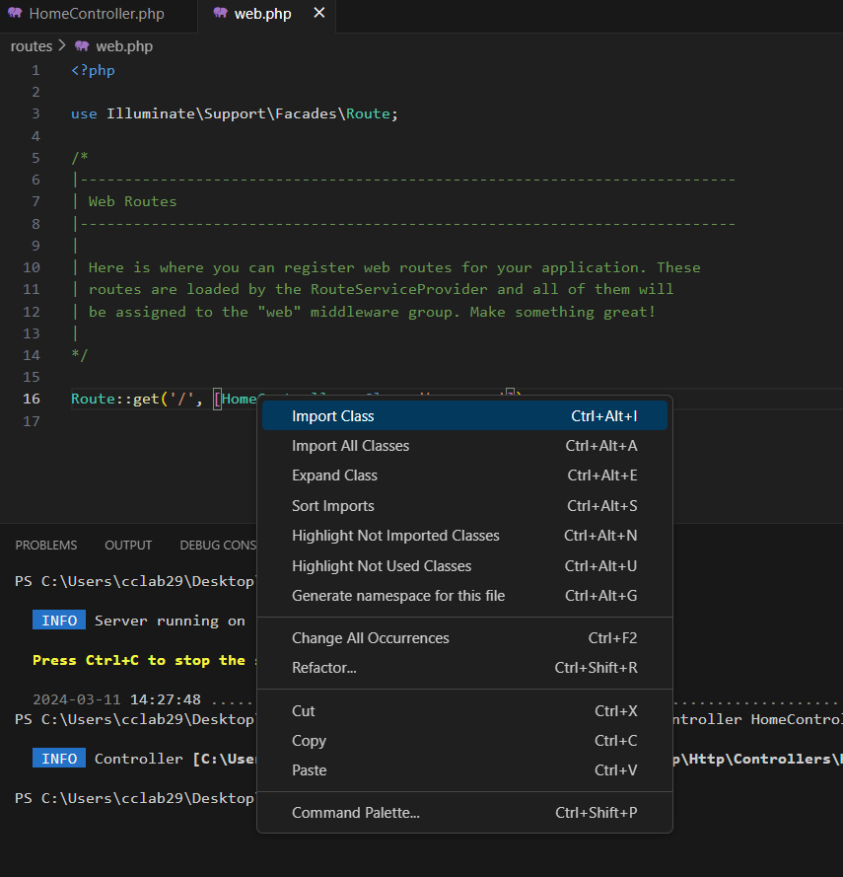

**7. In *resources->views->***

*Create new page homepage.blade.php*

*Write some code*

**8. in Homecontroller**

return view('homepage');

then the page homepage.blade.php will be displayed

**9. In resources->views->**

Create new folder components – to include the common files like header,footer etc

**10. in components folder cxreate new file layout.blade.php**

**And copy the header and footer from homepage.balde.php**

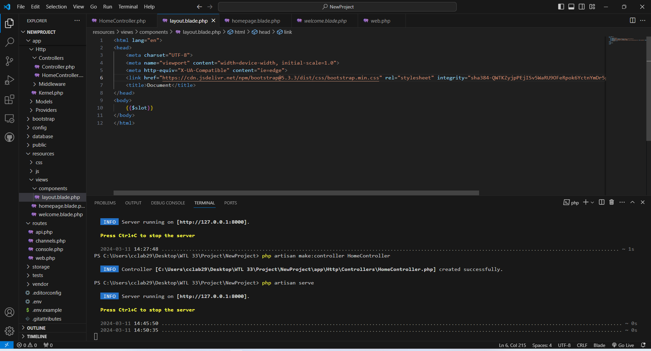

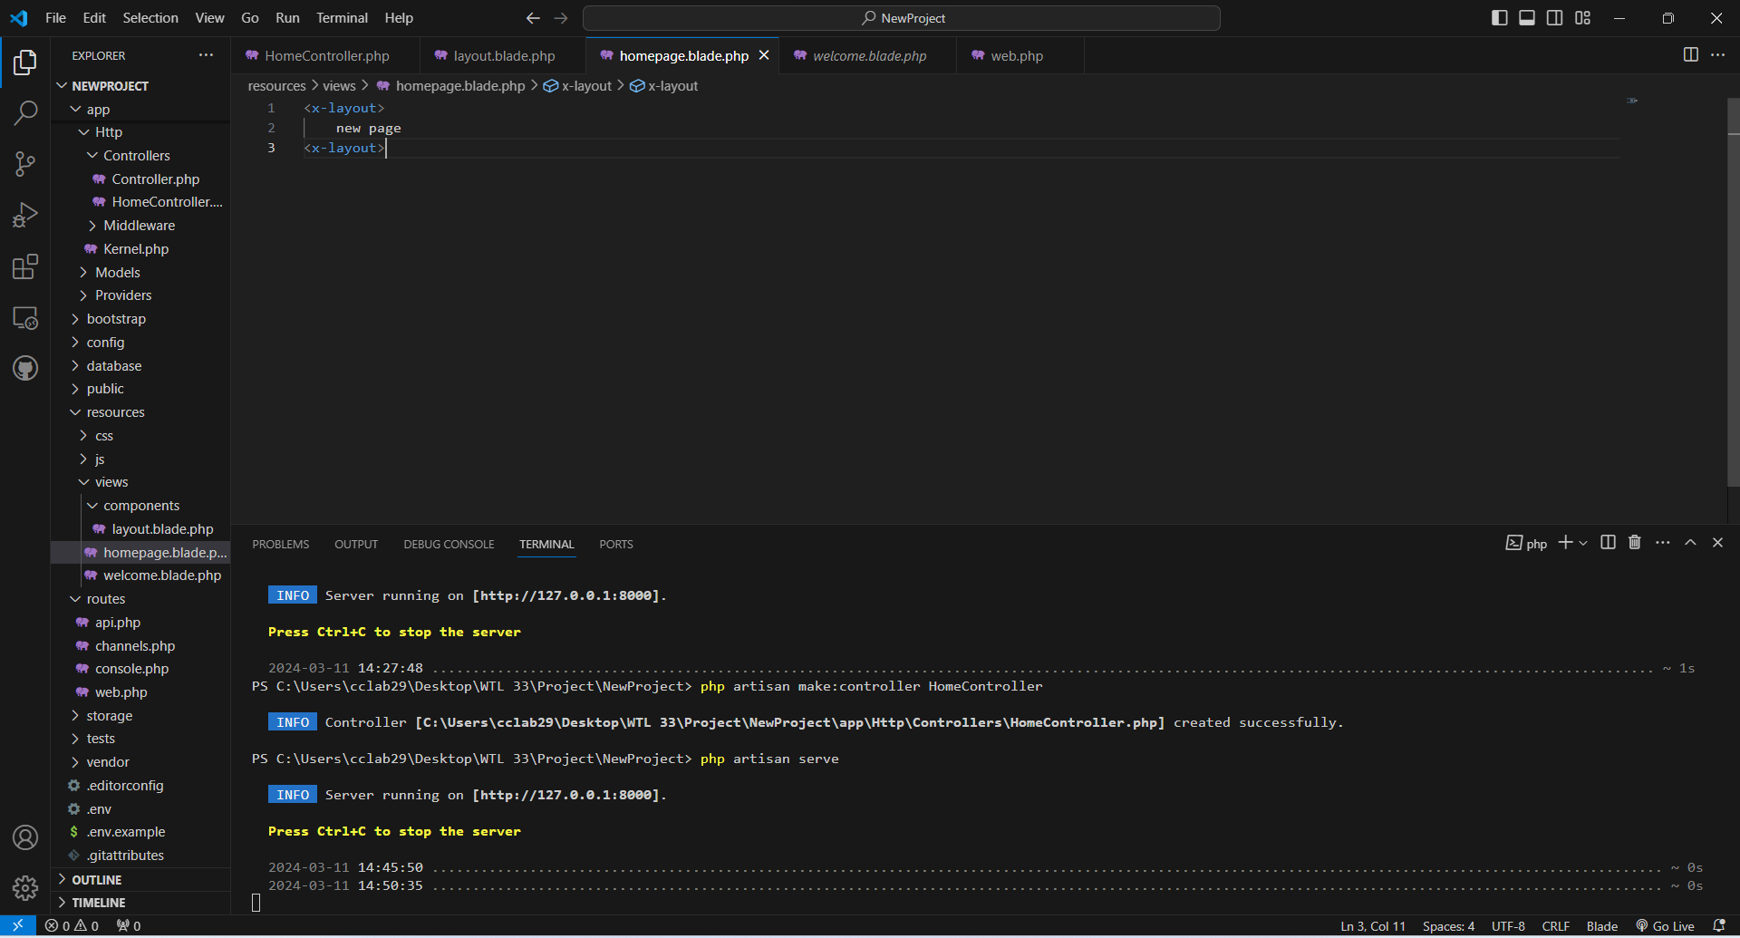   </x-layout>

**11. open the boostrap copy the code for navbar and form and paste it in the homepage.blade.php**

**12. paste the form code inside div class container to get it aligned**

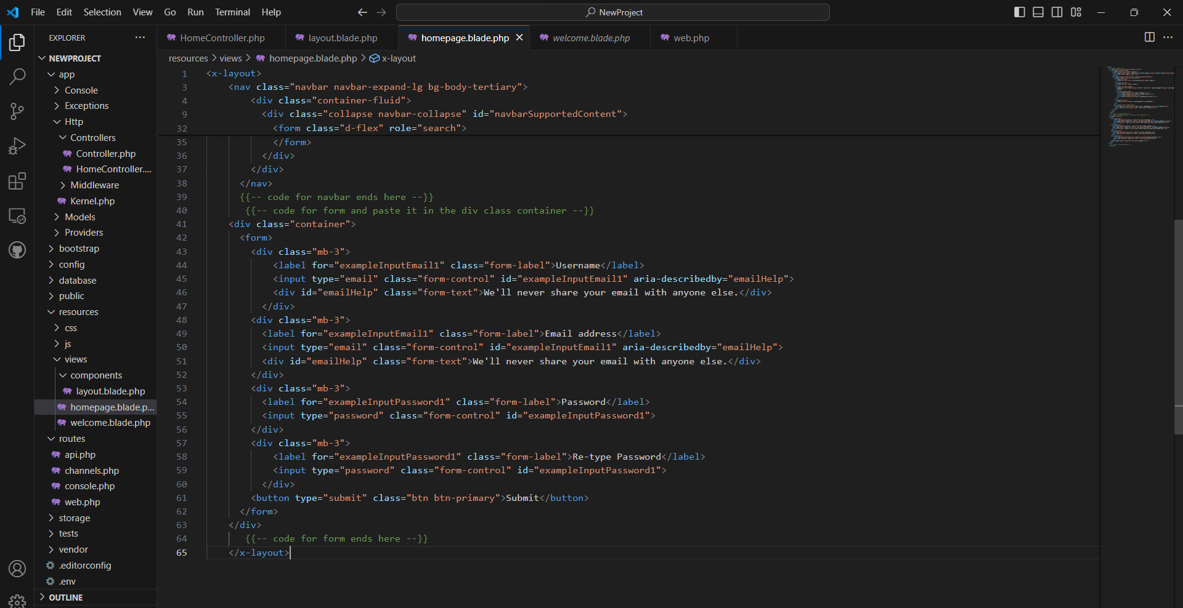

**13. copy paste the fields to create username and re-type password**

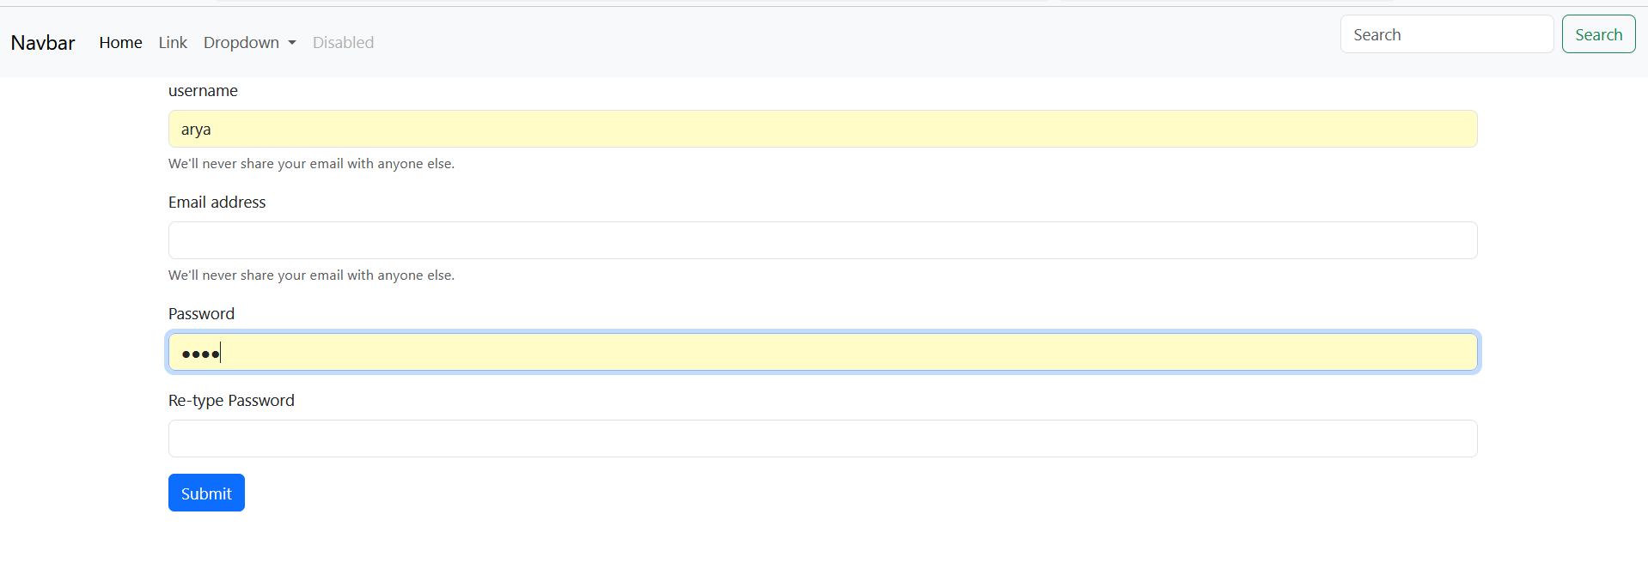

**14. the code for navbar should be in the layout.blade.php**

**15. in the homapge.blade.php <form action=”register” method=”POST”>**

**16. in the web.php**

**17. create new controller UserController and write the function register inside that**

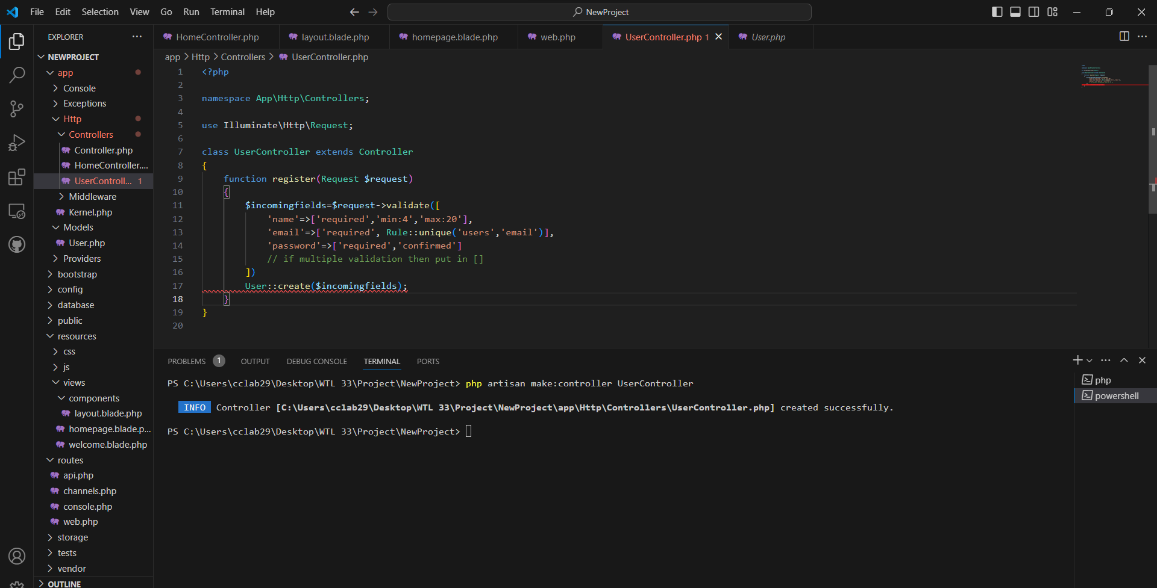

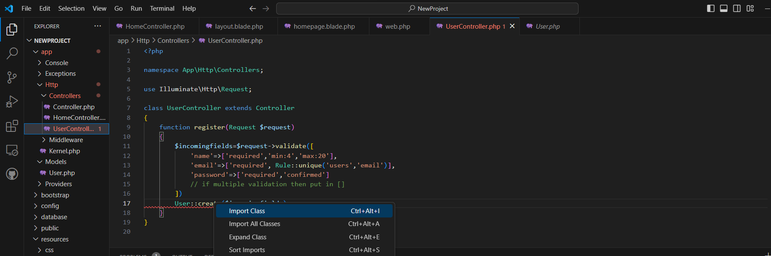

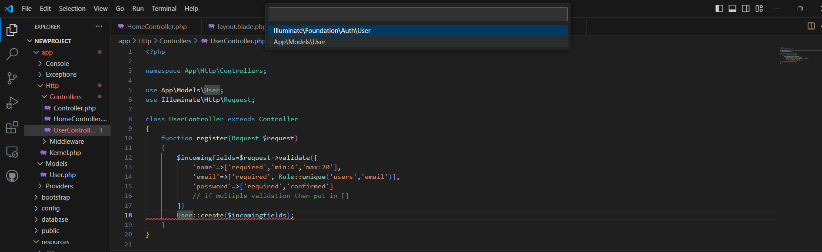

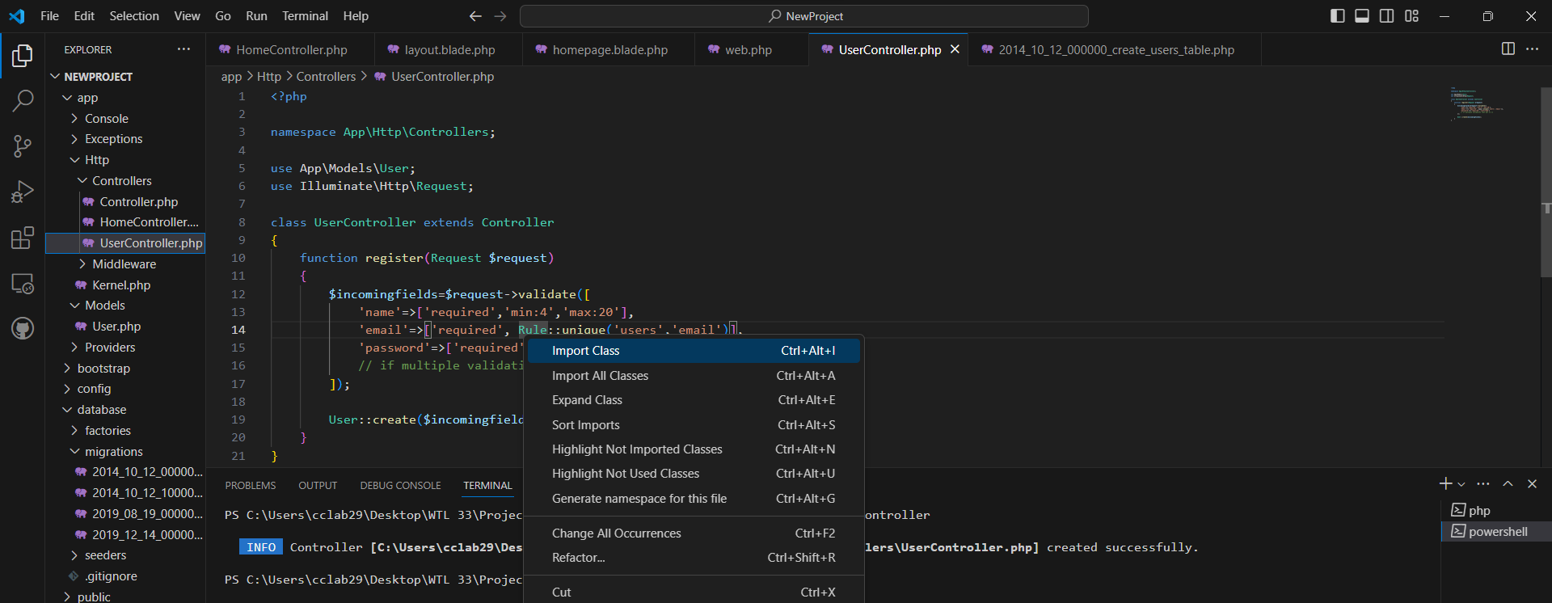

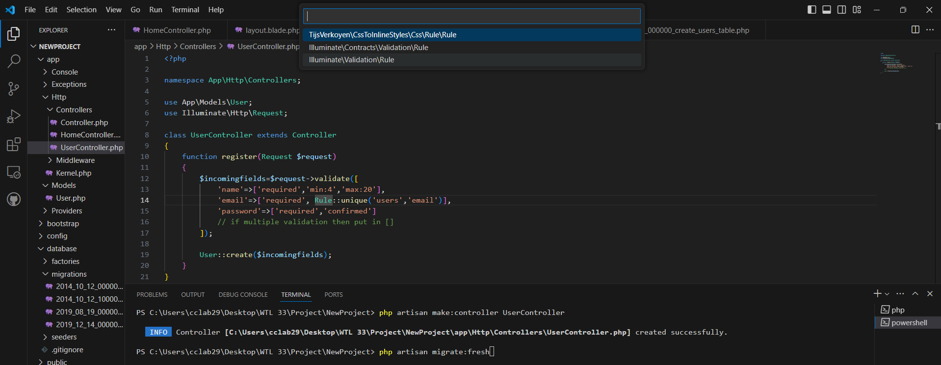

**18. open mysql workbench**

**Creatye new schema**

**19. .env file check password and username and database name**

**20. *database->migrations->in that first file***

***Php artisan migrate:fresh***

**21. in homepage.blade.php make changes in code**

**@csrf**

  @error('name')

            {{$MESSAGE}}

            @enderror

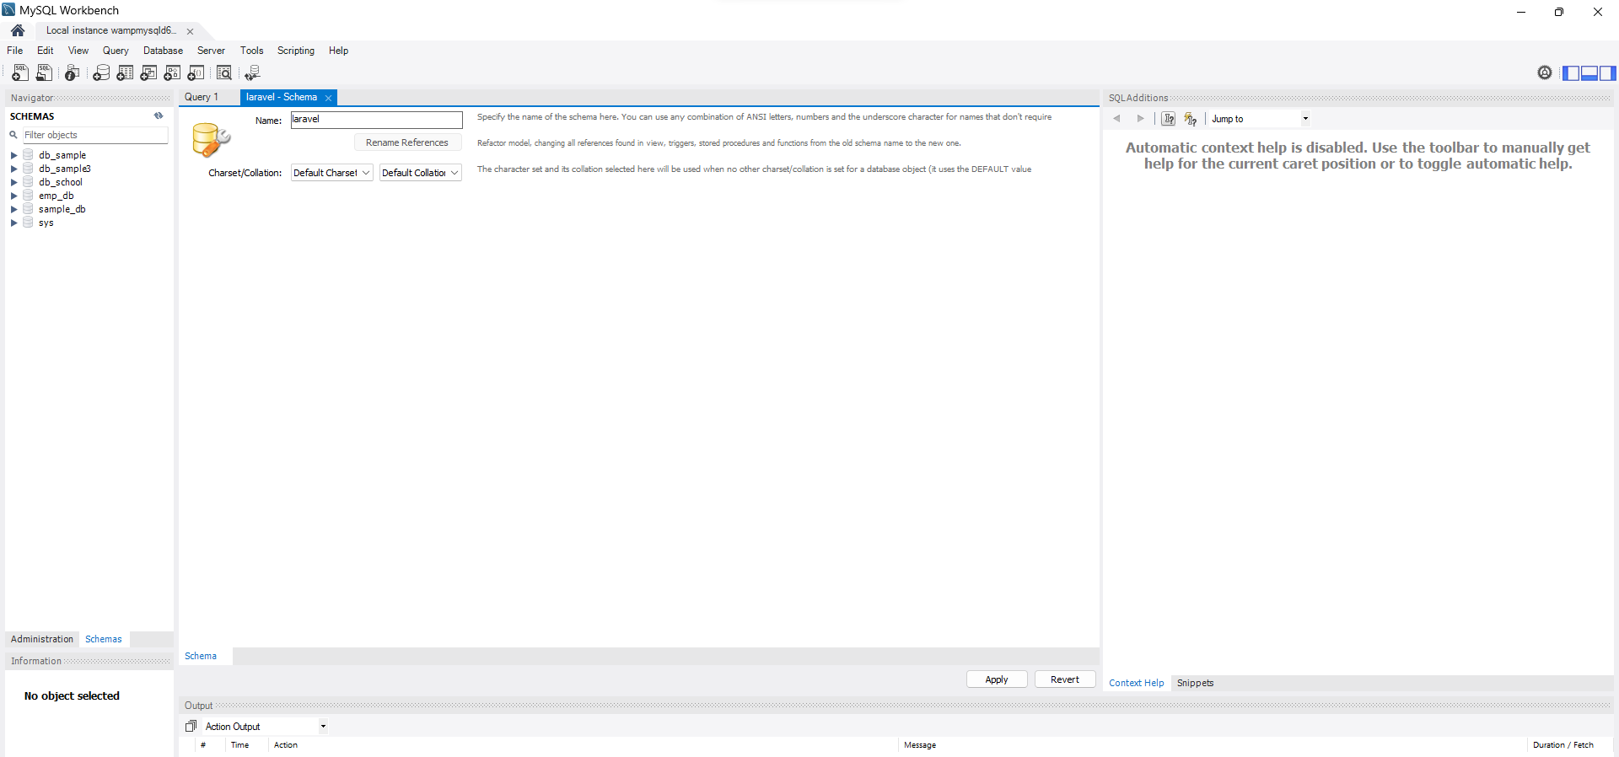

**php artisan make: model Product –migration //model is the table product**

**[app->models->product]**

**$table->string(‘product_name’)**